Circles-Questions
Key Stage 3: 2003 Paper 1 Level 5-7
1.
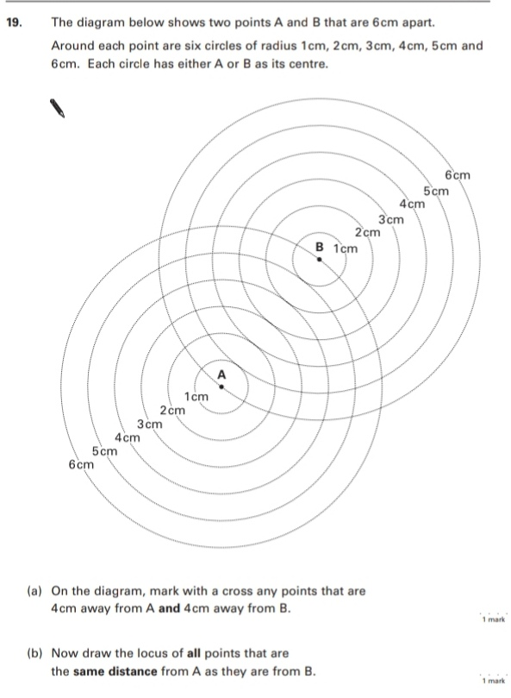
Key Stage 3: 2003 Paper 1 Level 6-8
2.
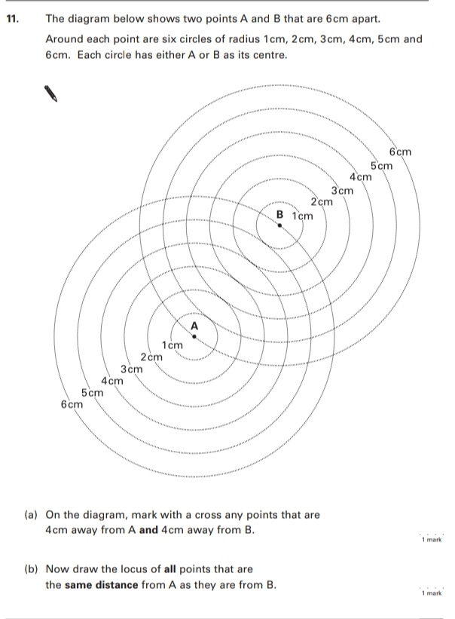
3.
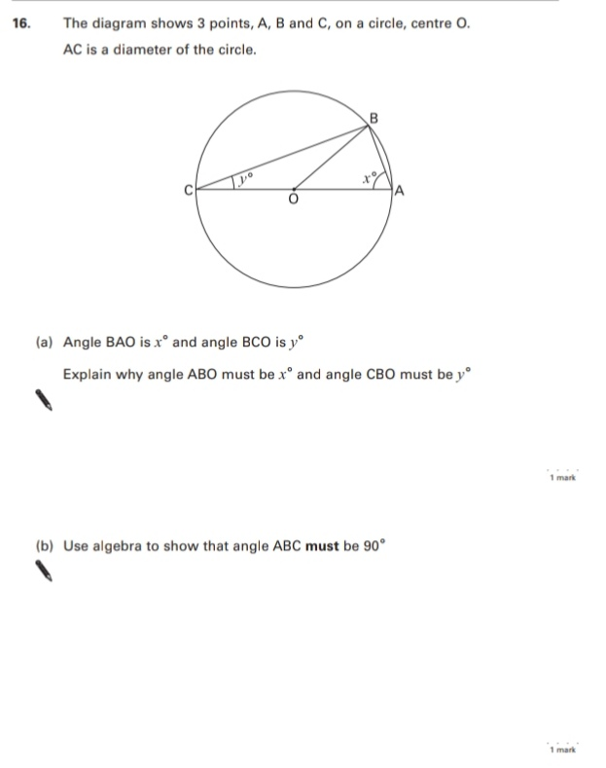
Key Stage 3: 2004 Paper 2 Level 5-7
4.
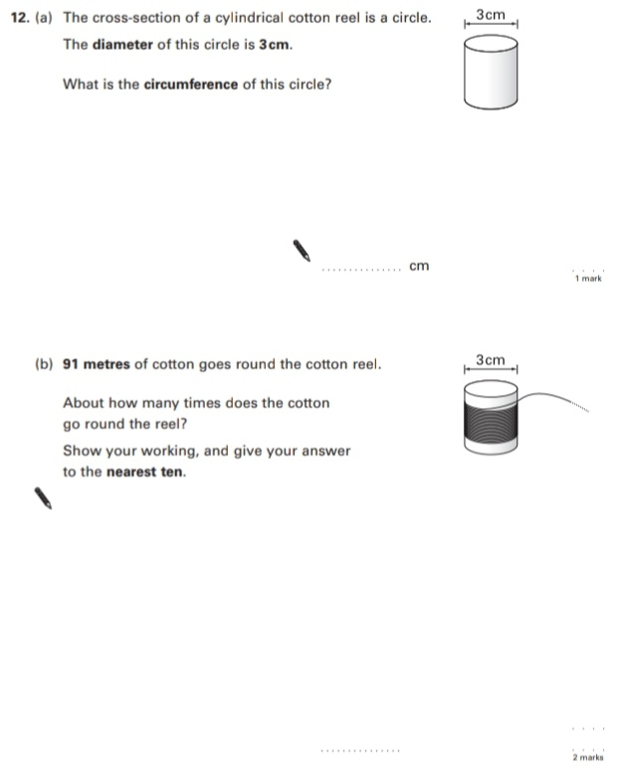
Key Stage 3: 2004 Paper 2 Level 6-8
5.
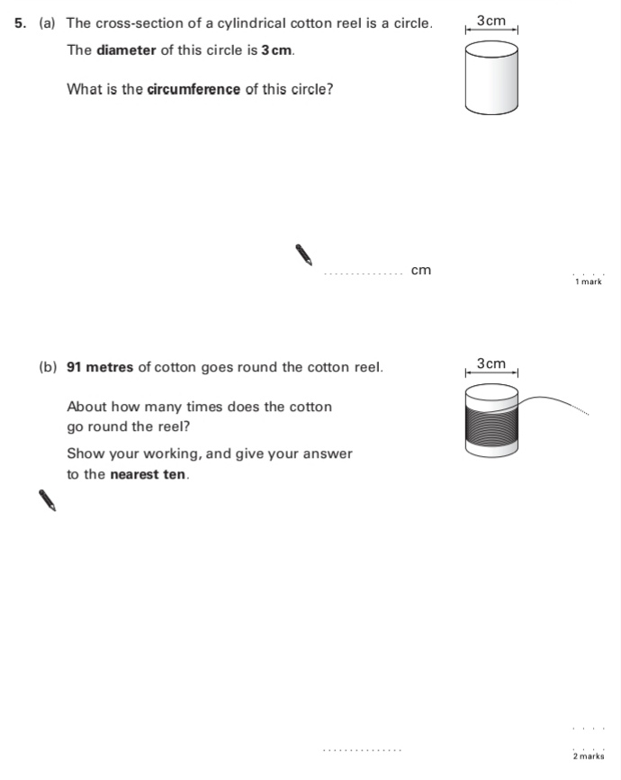
Key Stage 3: 2005 Paper 2 Level 5-7
6.
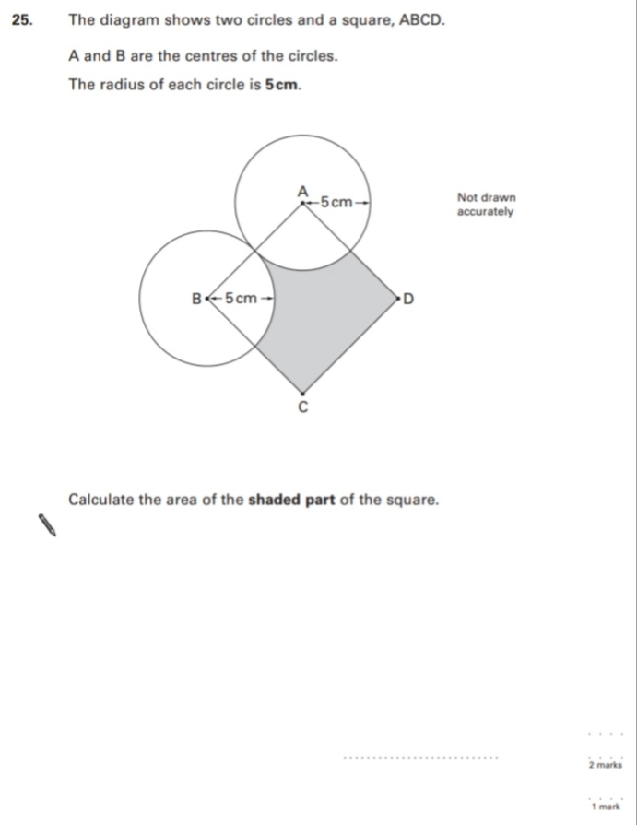
Key Stage 3: 2005 Paper 2 Level 6-8
7.
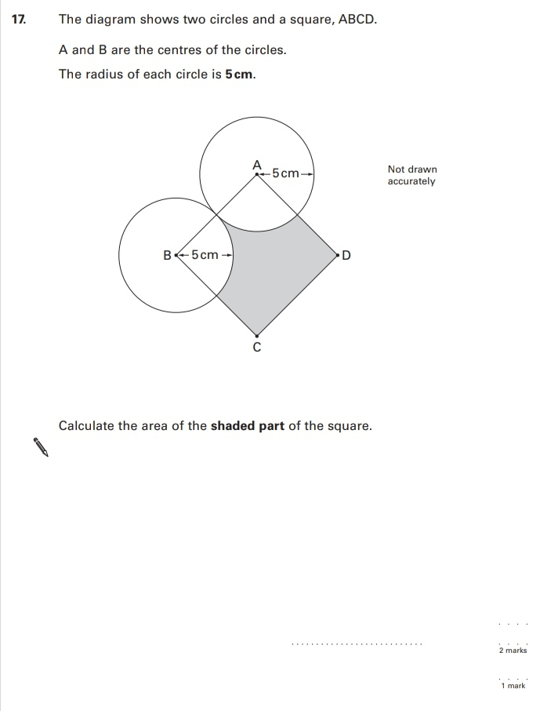
8.
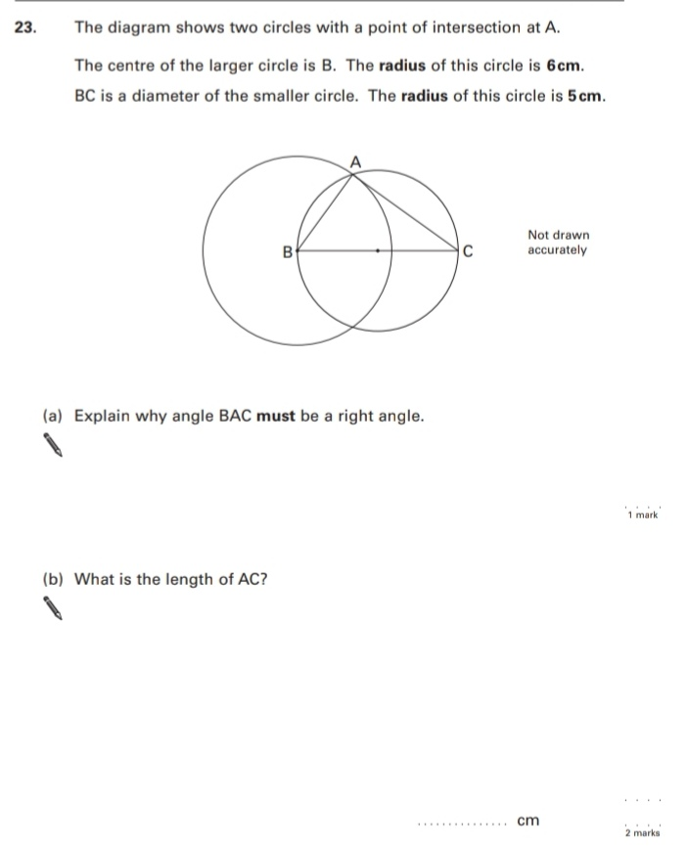
Key Stage 3: 2006 Paper 1 Level 6-8
9.
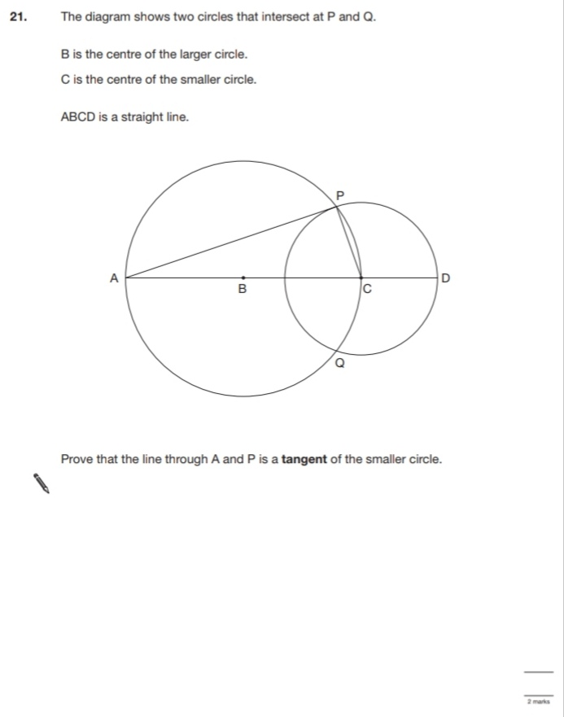
Key Stage 3: 2007 Paper 1 Level 5-7
10.
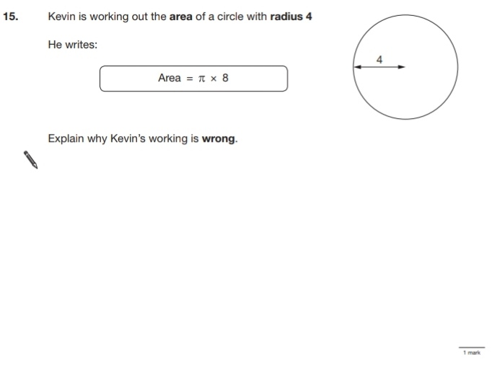
Key Stage 3: 2007 Paper 2 Level 5-7
11.
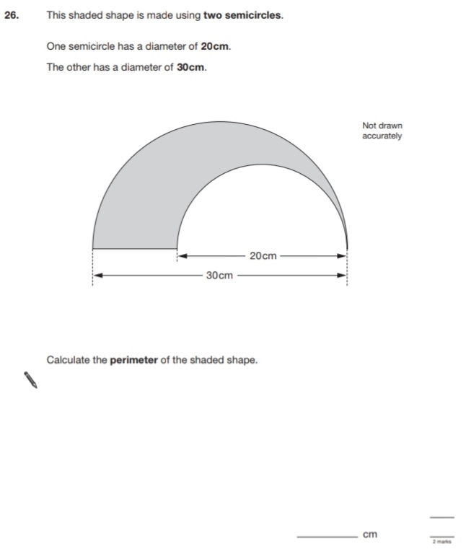
Key Stage 3: 2007 Paper 1 Level 6-8
12.
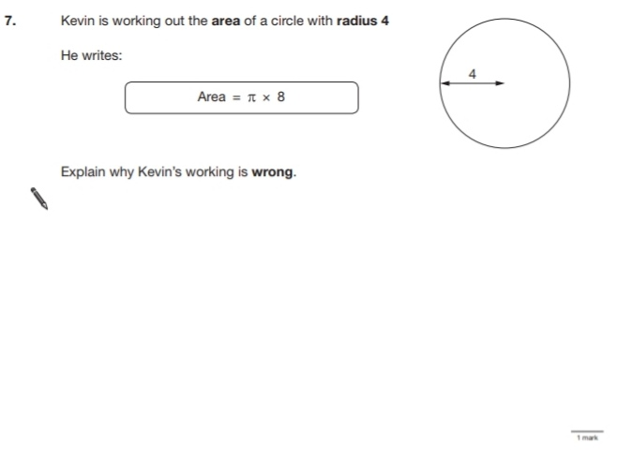
13.
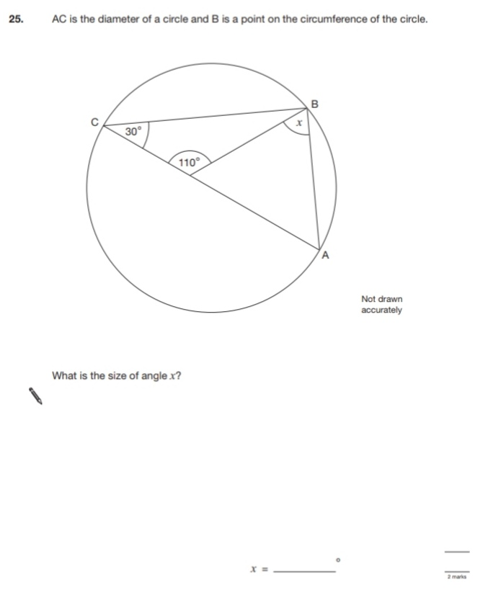
Key Stage 3: 2007 Paper 2 Level 6-8
14.
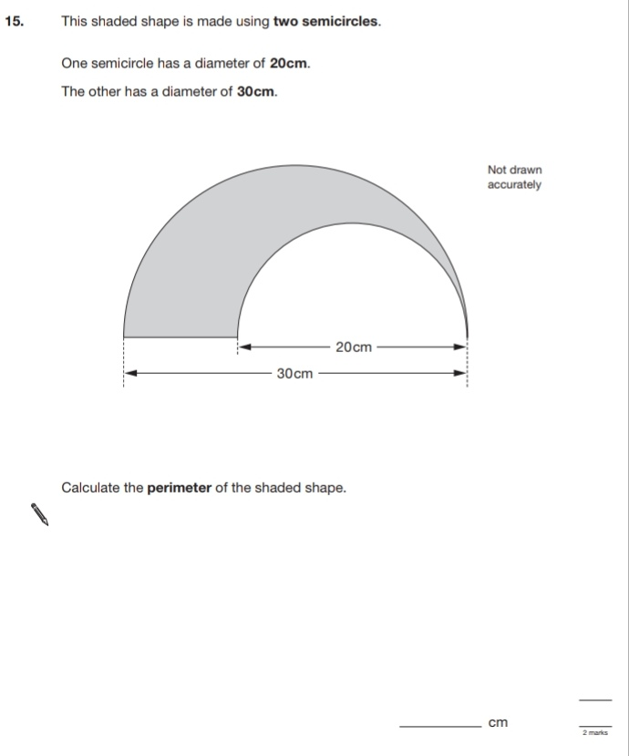
Key Stage 3: 2008 Paper 2 Level 3-5
15.
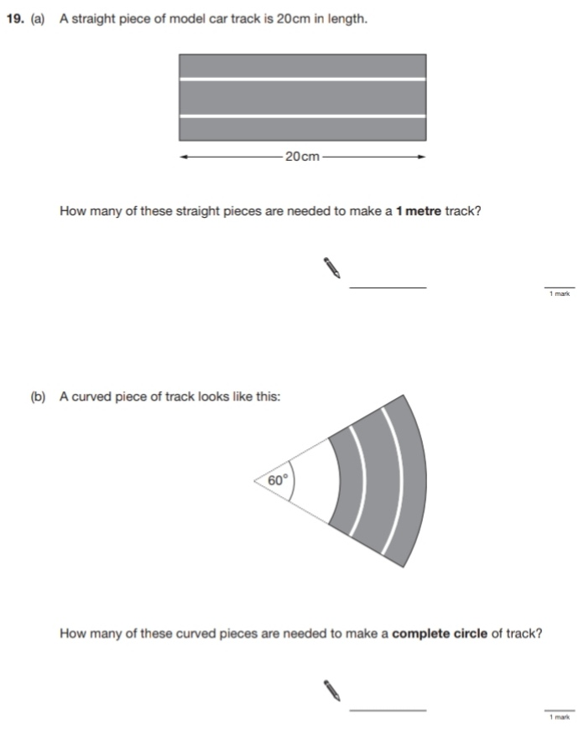

Key Stage 3: 2008 Paper 2 Level 4-6
16.
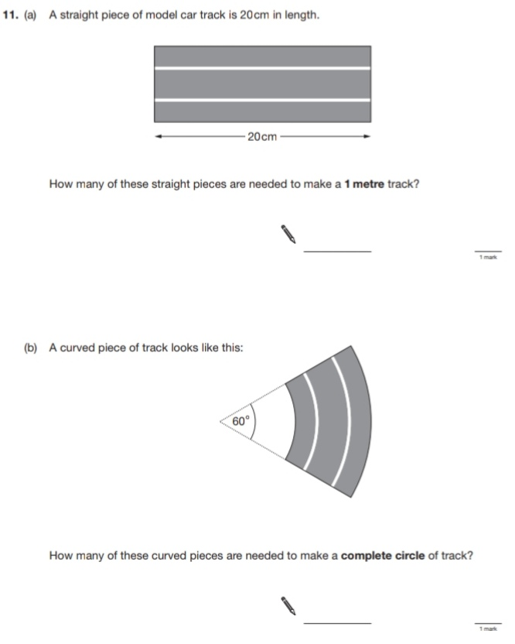

Key Stage 3: 2008 Paper 2 Level 5-7
17.
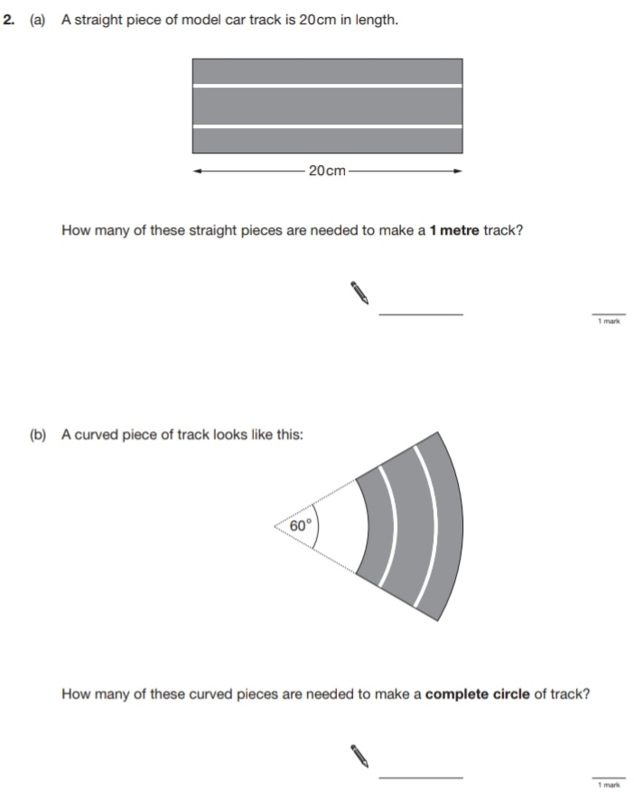
18.
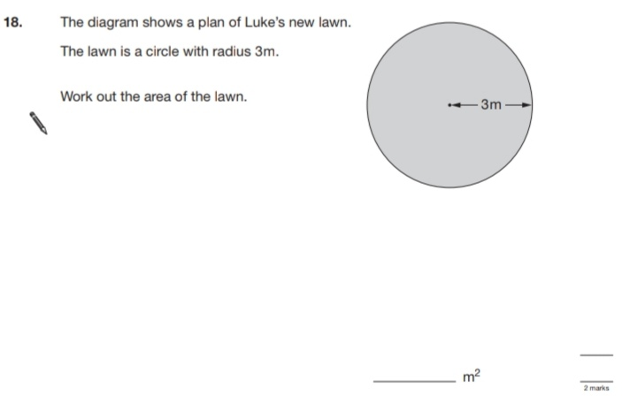
Key Stage 3: 2008 Paper 2 Level 6-8
19.
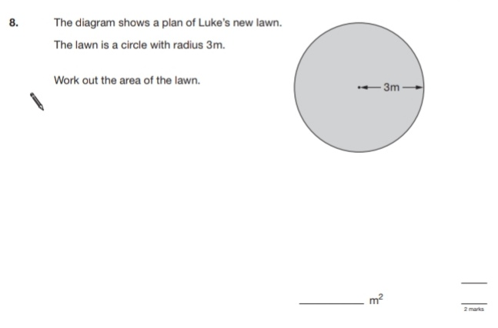
20.
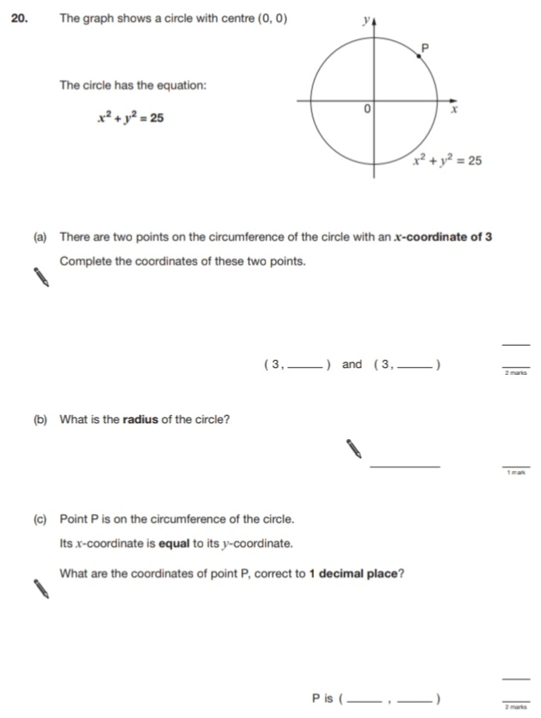
21.
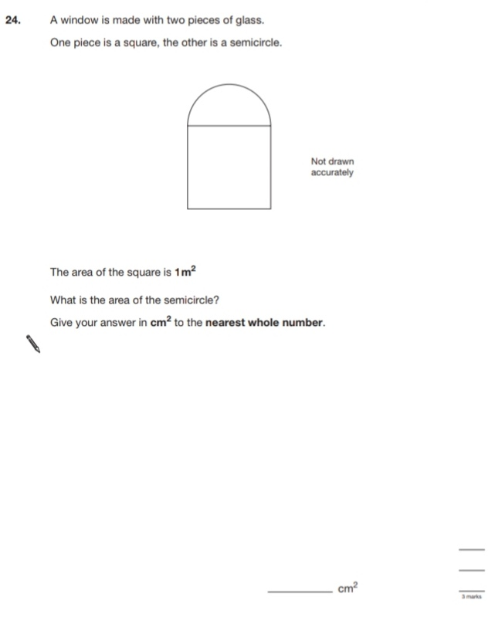
Key Stage 3: 2009 Paper 2 Level 5-7
22.
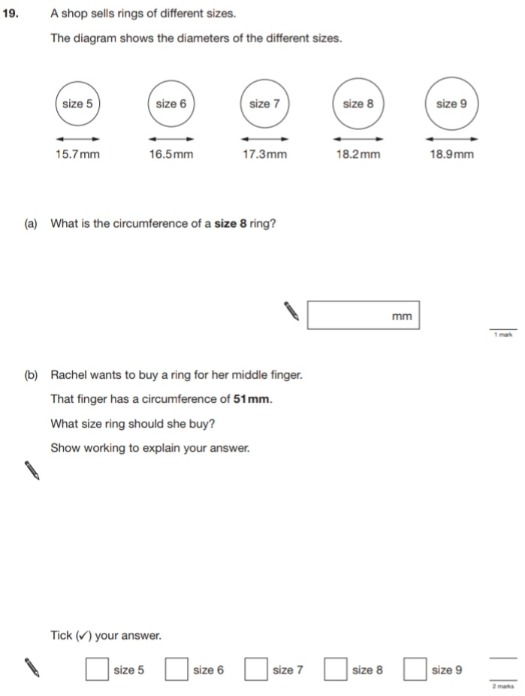
Key Stage 3: 2009 Paper 2 Level 6-8
23.
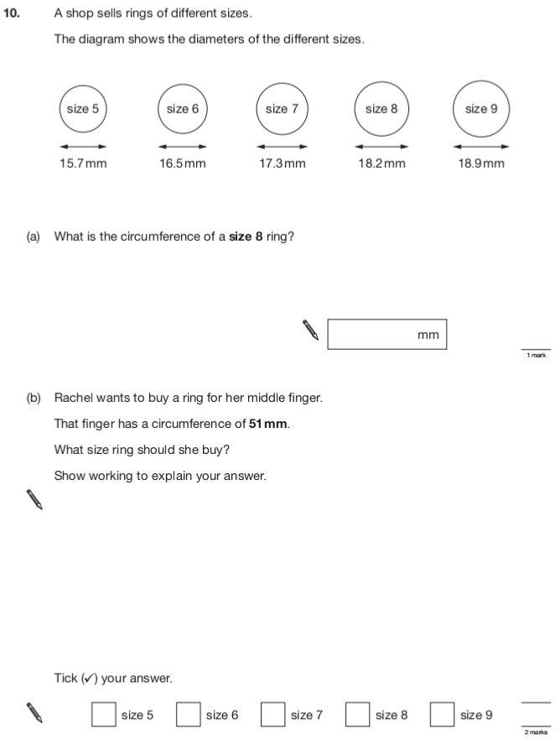
Key Stage 3: 2011 Paper 2 Level 5-7
24.
